**INTRODUCTION**

This document specially containing details about objectives, scope limitation, process model, primary requirements, team development, possible project risks, project schedule, and finally monitoring and reporting mechanisms.

Online Quiz is very useful for Educational Institute to prepare an exam, safe the time that will take to check the test and prepare marks. It will help the Institute to testing of students and develop their skills. But the disadvantages for this system, it takes a lot of times when you prepare the exam at the first time for usage. And we are needs number of computers with the same number of students.

The effective use of "Online Quiz", any Educational Institute or training centers can be use it to develop their strategy for putting the exams, and for getting better results in less time.

**SCOPE OF WORK**

Scope of this project is very broad in terms of other manually taking exams. Few of them are:-

* This can be used in educational institutions as well as in corporate world.
* Can be used anywhere any time as it is web based applications.
* Design to facilitate Administrator and User.
* The type of question is only Multiple choice.
* The system handles add operation and generate result as soon as the test is finish.
* Online Quiz is designed for educational institutes like schools, colleges and private institutes to conduct logic tests of their students or employees on regular basis.
* The proposed system takes advantage of advance made in IT to provide large qualitative and quantitative improvements.

**NEED FOR WEBSITE**

The traditional approach to measuring a person’s level of knowledge in topic has been quiz. These days there is often more emphasis on internal assessment, which may consist of assignment and project given out by the teacher and marked or assessed by the same teacher.

It is a modern method of conducting quiz widely accepted and hastily increased environment of conducting exam through online in all the sectors of education and job. It will considerably replace the traditional paper and pen-based exam in future. In present days the availability of computers and wide spread nature of internet has led a strong foundation paths for conducting quiz. Online quiz offers the following features that grow light on its need today is reliability and User details.

**OPERATING ENVIRONMENT- HARDWARE AND SOFTWARE**

Technology (Language) used to develop this Software.

1. HTML
2. CSS
3. JAVASCRIPT
4. PHP
5. MYSqli
6. Wamp server

**Hardware Requirements:-**

1. RAM- 2 GB
2. Hard disk- 1TB
3. Processor- Intel® Core™ i3

**ABOUT THE PLATFORM**

About the PHP:-

PHP is a server-side scripting language designed for web development but also used as a general-purpose programming language. It is originally created by Rasmus Lerdorf in 1994; the PHP reference implementation is now produced by the PHP Group. PHP originally stood for Personal Home Page, but it now stands for the recursive acronym PHP: Hypertext Preprocessor.

PHP is widely-used open source general-purpose scripting language that is especially suited for web development & can be embedded into HTML. Much of its syntax is borrowed from C, java, & Perl with a couple of unique PHP-specific thrown in. The goal of the language is to allow web developers to write dynamically generated pages quickly. PHP/FI 2.0 is an early and no longer supported version of PHP. PHP 3 is the successor to PHP/FI 2.0 is a lot nicer. PHP 7 is the current generation of PHP, which uses the Zend engine 3 which, among other things, offers many additional OOP features.

About MySQL-

MySQL is an open source relational database management system. Its name is a combination of “My”, the name of co-founder Michael Widenius’s daughter and “SQL”, the abbreviation for structured Query Language. The MySQL development project has made its source code available under the terms of the GNU General Public License, as well as under a variety of proprietary agreements. MySQL was owned and sponsored by a single for-profit firm, the Swedish company MySQL AB, now owned by Oracle Corporation. For proprietary use, several paid editions are available, and offer additional functionality.

**SYSTEM DESIGN**

Flow Chart-

**E.R.D**

User

Register

Go to

Registration

Examination

Receive

Exam Result

Result

Log In

Perform

**D.F.D**

0 Level DFD-

Quiz Registration Exam Info.

User

Admin

Success registration

1 Level DFD-

Registered User

Users Data

2 Level DFD-

Test

Quiz Test

Users Data

**Database Design**

**Exam Database-**

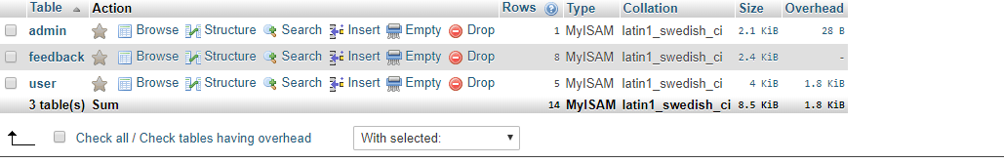

**Admin Login-**

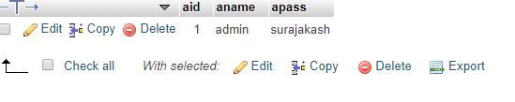

**Feedback-**

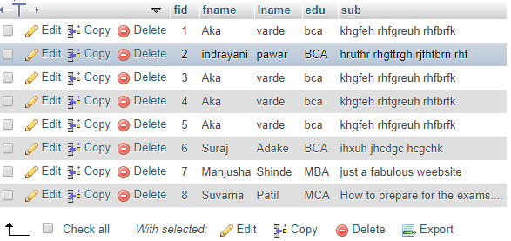

**Log in**

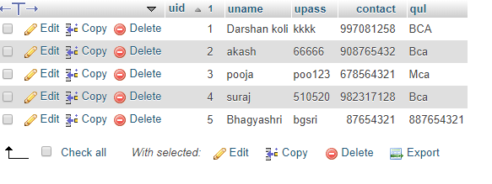

**Current Affairs (choices)**

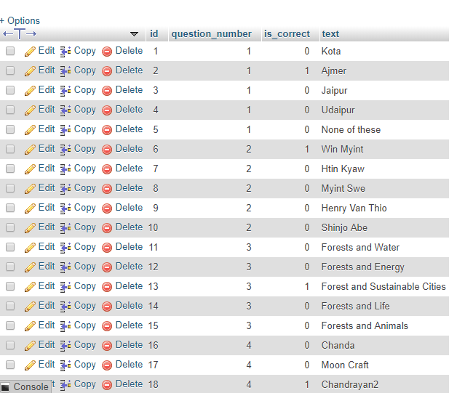

**Current Affairs (questions)**

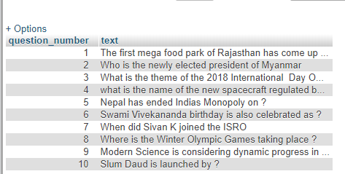

**SITE MAP**

Home Page

Contact Us

**Admin Login**

About Us

Sign In

Feedback

Home

Logout

About Us

Register

Home

Contact US

Add Questions

Current Affairs

Computer Concepts

Home

General Aptitude

Home

English Skill

Home

**DESIGN OF CODE**

**Home.php**

**<html>**

**<head>**

**<link rel="stylesheet" href="nav.css">**

**<link href="https://fonts.googleapis.com/css?family=Fjalla+One|Rammetto+One|Days+One" rel="stylesheet">**

**<link href="https://fonts.googleapis.com/css?family=Contrail+One" rel="stylesheet">**

**<link href="https://fonts.googleapis.com/css?family=Anton" rel="stylesheet">**

**<meta name="viewport" content="width=device-width, initial-scale=1">**

**<meta name="viewport" content="width=device-width, initial-scale=1">**

**<meta name="viewport" content="width=device-width, initial-scale=1">**

**<link rel="stylesheet" href="https://cdnjs.cloudflare.com/ajax/libs/font-awesome/4.7.0/css/font-awesome.min.css">**

**</head>**

**<body bgcolor=white>**

**<div class="navbar">**

**<img src="images/1.jpg" height=50 width=80 ></img>**

**<img src="images/2.png" height=50 width=300 ></img>**

**<a href="contact.php">CONTACT US</a>**

**<a href="about.php">ABOUT US</a>**

**<a href="sign.php">SIGN IN</a>**

**<a href="home.php">HOME</a>**

**</div>**

**<div class="mySlides">**

**<br>**

**<pre class="head">**

**Success dosen't**

**come to you,**

**You go to it..</pre>**

**<div style="height:270px;width:1000px;background-color:tan;margin-left:170px;border-radius:20px;object-position:20px;bottom:20px;">**

**<h4 style="text-align:center;font-family:arial;"><i class="fa fa-hand-o-right" style="font-size:28px;color:red"></i>CLICK HERE TO WATCH THIS VIDEO<i class="fa fa-hand-o-left" style="font-size:28px;color:red"></i></h4>**

**<video width="380" height="210" style="margin-left:100px;" controls>**

**<source src="images/mv1.mp4" type="video/mp4">**

**<source src="images/mv1.mp4" type="video/ogg">**

**</video>**

**<video width="380" height="210" style="margin-left:40px;" controls>**

**<source src="images/mv2.mp4" type="video/mp4">**

**<source src="images/mv2.mp4" type="video/ogg">**

**</video></div>**

**</div>**

**<div class="mySlides1" >**

**<div class="hero-text" style="top:260px;height:200px;width:650px;border-radius:50px;">**

**<br>**

**<h1 style="font-size:30px;font-family:arial;style:Bold Italic">PLEASE GIVE YOUR FEEDBACK</h1>**

**<p style="font-size:20px;font-family: 'Rammetto One', cursive;style:Bold Italic">YOUR FEEDBACK IS IMPORTANT FOR US</p>**

**<button onclick="location.href='feedback.php'">ENTER</button>**

**</div>**

**</div>**

**<div >**

**<div class="navbar2">**

**<a href="contact.php">CONTACT US</a>**

**<a href="sign.php">SIGN IN</a>**

**<a href="adminlogin.php">Admin</a>**

**</div>**

**<div style="background-color: black">**

**&nbsp&nbsp&nbsp&nbsp&nbsp&nbsp&nbsp&nbsp&nbsp&nbsp&nbsp&nbsp<a href="www.instagram.com"><img src="images/10.png" height=30 width=30 ></img></a>**

**&nbsp&nbsp&nbsp&nbsp&nbsp&nbsp&nbsp&nbsp&nbsp&nbsp&nbsp&nbsp**

**<a href="www.twitter.com"><img src="images/11.png" height=30 width=30 ></img></a>&nbsp&nbsp&nbsp&nbsp&nbsp&nbsp&nbsp&nbsp&nbsp&nbsp&nbsp&nbsp**

**<a href="www.google.com"><img src="images/12.png" height=30 width=30 ></img></a></img>&nbsp&nbsp&nbsp&nbsp&nbsp&nbsp&nbsp&nbsp&nbsp&nbsp&nbsp&nbsp**

**<a href="www.facebook.com"><img src="images/13.png" height=30 width=30 ></img></a>&nbsp&nbsp&nbsp&nbsp&nbsp&nbsp&nbsp&nbsp&nbsp&nbsp&nbsp&nbsp**

**<a href="www.gmail.com"><img src="images/14.png" height=30 width=30 ></img></a>&nbsp&nbsp&nbsp&nbsp&nbsp&nbsp&nbsp&nbsp&nbsp&nbsp&nbsp&nbsp**

**<div><p class="navbar3" >All copyrights &copy are reserved</div>**

**</div>**

**</div>**

**</body>**

**</html>**

**Sign.php**

**<html>**

**<head>**

**<script>**

**function validateForm() {**

**var x = document.forms["myForm"]["submit"].value;**

**if (x == "") {**

**alert("Name must be filled out");**

**return false;**

**}**

**}**

**</script>**

**<link rel="stylesheet" href="nav.css">**

**<link href="https://fonts.googleapis.com/css?family=Fjalla+One|Rammetto+One|Days+One" rel="stylesheet">**

**<link href="https://fonts.googleapis.com/css?family=Anton" rel="stylesheet">**

**<meta name="viewport" content="width=device-width, initial-scale=1">**

**<style>**

**form {**

**border: 4px solid #f1f1f1;**

**background-color:#FFEE58;**

**width:40%;**

**margin-left:400px;**

**border: 2px solid black;**

**border-radius:30px;**

**}**

**input[type=text], input[type=password] {**

**width: 100%;**

**padding: 12px 20px;**

**margin: 8px 0;**

**display: inline-block;**

**border: 2px solid #ccc;**

**box-sizing: border-box;**

**}**

**button {**

**background-color: green;**

**color: white;**

**padding: 14px 20px;**

**margin: 8px 0;**

**border: none;**

**cursor: pointer;**

**width: 100%;**

**}**

**button:hover {**

**opacity: 0.8;**

**}**

**.cancelbtn {**

**width: auto;**

**padding: 10px 18px;**

**background-color: #f44336;**

**}**

**.imgcontainer {**

**text-align: center;**

**margin: 24px 0 12px 0;**

**}**

**img.avatar {**

**width: 40%;**

**border-radius: 60%;**

**}**

**.container {**

**padding: 16px;**

**}**

**span.psw {**

**float: right;**

**padding-top: 16px;**

**font-family:arial black;**

**}**

**/* Change styles for span and cancel button on extra small screens */**

**@media screen and (max-width: 300px) {**

**span.psw {**

**display: block;**

**float: none;**

**}**

**.cancelbtn {**

**width: 50%;**

**}**

**}</style>**

**</head>**

**<body style="background-image:url(images/45.jpg);background-size:cover;">**

**<div class="navbar">**

**<img src="images/1.jpg" height=50 width=80 ></img>**

**<img src="images/2.png" height=50 width=300 ></img>**

**<a href="contact.php">CONTACT US</a>**

**<a href="about.php">ABOUT US</a>**

**<a href="sign.php">SIGN IN</a>**

**<a href="home.php">HOME</a>**

**</div>**

**<div>**

**<?php**

**$con=mysqli_connect("localhost","root","","exam");**

**?>**

**<?php**

**if(isset($_GET['submit']))**

**{**

**$sql1="select * from user where uname='".$_GET['uname']."' and upass='".$_GET['upass']."'";**

**$result= mysqli_query($con,$sql1);**

**$i=mysqli_fetch_assoc($result);**

**if(isset($i['uid']))**

**{**

**echo'<script>window.location="home2.php"</script>';**

**}**

**else**

**{**

**echo"Wrong username and password";**

**}**

**}**

**else{**

**echo"Please Login";**

**}**

**?><br><br>**

**<h1 align="center" style="font-family:arial black;margin-top:20px;text-decoration:underline;color:black;"><span style="height:40px;width:100px;background-color:tan;border-radius:10px;">Login Form</span></h1>**

**<form method="GET" onsubmit="return validateForm()" name="myForm" style="background-color: #ff7043">**

**<div class="imgcontainer">**

**<img src="images\20.jpg" alt="Avatar" class="avatar">**

**</div>**

**<div class="container">**

**<label for="uname"><b>Username</b></label>**

**<input type="text" placeholder="Enter Username" name="uname" value="" size=25 required>**

**<label for="psw"><b>Password</b></label>**

**<input type="password" placeholder="Enter Password" name="upass" value="" size=25 required>**

**<button type="submit" name="submit" value="submit" >Login</button>**

**<label>**

**<input type="checkbox" checked="checked" name="remember"> Remember me**

**</label>**

**</div>**

**<div class="container" style="background-color:#f1f1f1;border: 2px solid black;border-radius:25px;">**

**<button type="button" class="cancelbtn" onclick="location.href='home.php'">Cancel</button>**

**<span class="psw">NEW USER&nbsp&nbsp<a href="register.php">REGISTER HERE...</a></span>**

**</div>**

**</form>**

**<div >**

**<div class="navbar2">**

**<a href="contact.php">CONTACT US</a>**

**<a href="sign.php">SIGN IN</a>**

**</div>**

**<div style="background-color: black">**

**&nbsp&nbsp&nbsp&nbsp&nbsp&nbsp&nbsp&nbsp&nbsp&nbsp&nbsp&nbsp<a href="www.instagram.com"><img src="images/10.png" height=30 width=30 ></img></a>**

**&nbsp&nbsp&nbsp&nbsp&nbsp&nbsp&nbsp&nbsp&nbsp&nbsp&nbsp&nbsp**

**<a href="www.twitter.com"><img src="images/11.png" height=30 width=30 ></img></a>&nbsp&nbsp&nbsp&nbsp&nbsp&nbsp&nbsp&nbsp&nbsp&nbsp&nbsp&nbsp**

**<a href="www.google.com"><img src="images/12.png" height=30 width=30 ></img></a></img>&nbsp&nbsp&nbsp&nbsp&nbsp&nbsp&nbsp&nbsp&nbsp&nbsp&nbsp&nbsp**

**<a href="www.facebook.com"><img src="images/13.png" height=30 width=30 ></img></a>&nbsp&nbsp&nbsp&nbsp&nbsp&nbsp&nbsp&nbsp&nbsp&nbsp&nbsp&nbsp**

**<a href="www.gmail.com"><img src="images/14.png" height=30 width=30 ></img></a>&nbsp&nbsp&nbsp&nbsp&nbsp&nbsp&nbsp&nbsp&nbsp&nbsp&nbsp&nbsp**

**<div><p class="navbar3" >All copyrights are reserved</div>**

**</div>**

**</div>**

**</body>**

**</html>**

**Register.php**

**<html>**

**<head>**

**<link rel="stylesheet" href="nav.css">**

**<link rel="stylesheet" href="reg.css">**

**<link href="https://fonts.googleapis.com/css?family=Fjalla+One|Rammetto+One|Days+One" rel="stylesheet">**

**<link href="https://fonts.googleapis.com/css?family=Anton" rel="stylesheet">**

**<meta name="viewport" content="width=device-width, initial-scale=1">**

**</head>**

**<body bgcolor=black>**

**<div class="navbar">**

**<img src="images/1.jpg" height=50 width=80 ></img>**

**<img src="images/2.png" height=50 width=300 ></img>**

**<a href="contact.php">CONTACT US</a>**

**<a href="about.php">ABOUT US</a>**

**<a href="sign.php">SIGN IN</a>**

**<a href="home.php">HOME</a>**

**</div>**

**<br>**

**<div>**

**<?php**

**$c=mysqli_connect("localhost","root","","exam")**

**?>**

**<?php**

**if (isset($_GET['Save']))**

**{**

**$sql="INSERT INTO `user`( `uname`, `upass`, `contact`, `qul`) values('".$_GET['txt1']."','".$_GET['txt2']."','".$_GET['txt3']."','".$_GET['txt4']."')";**

**$result=mysqli_query($c,$sql);**

**}**

**?>**

**</div>**

**<br>**

**<form method="GET" style="border:2px solid #ccc;background-image:url(images/45.jpg);background-size:cover;" >**

**<div class="container">**

**<h1 align="center" style="font-family:arial black;margin-top:10px;text-decoration:underline;color:black;"><span style="height:40px;width:100px;background-color:tan;border-radius:10px;">REGISTRATION FORM</span></h1>**

**<p style="text-align:center;color: white"><span style="height:40px;width:100px;background-color:black;border-radius:5px;">Please fill in this form to create an account.</span></p>**

**<hr>**

**<label for="email" style="margin-left:350px;color:black;font-family:arial;height:40px;width:100px;background-color:white;"><b>User Name</b></label><br>**

**<input type="text" name="txt1" placeholder="Enter User Name" value="<?php global $txt1; echo $txt1?>" style="margin-left:350px;width:700px" required>**

**<input type="hidden" name="id" value="<?php global $id; echo $id?>"><br>**

**<label for="psw" style="margin-left:350px;color:black;height:40px;width:100px;background-color:white;"><b>User Password</b></label><br>**

**<input type="text" name="txt2" placeholder="Enter User Password" value="<?php global $txt2; echo $txt2?>" style="margin-left:350px;width:700px" required><br>**

**<label for="psw" style="margin-left:350px;color:black;height:40px;width:100px;background-color:white;"><b>Contact No</b></label><br>**

**<input type="text" name="txt3" placeholder="Enter Contact No." value="<?php global $txt3; echo $txt3?>" style="margin-left:350px;width:700px" required><br>**

**<label for="psw-repeat" style="margin-left:350px;color:black;height:40px;width:100px;background-color:white;"><b>Qualification</b></label><br>**

**<input type="text" name="txt4" placeholder="Qualification" value="<?php global $txt4; echo $txt4?>" style="margin-left:350px;width:700px" required><br>**

**<label style="margin-left:600px;color:black;height:40px;width:100px;background-color:white;font-family:arial black;">**

**<input type="checkbox" checked="checked" name="remember" style="margin-left:05px;width:70px;"> Remember me**

**</label>**

**<p style="margin-left:450px;color: white">By creating an account you agree to our <a href="#" style="color:dodgerblue">Terms & Privacy</a>.</p>**

**<div class="clearfix">**

**<button type="button" class="cancelbtn" onclick="location.href='home.php'" style="margin-left:350px">Cancel</button>**

**<input type="Submit" value="Save" name="Save" class="signupbtn" style="background-color:green;margin-left:40px;border-style:none;padding: 14px 20px;opacity:1;color:white;margin-top:08px;opacity: 0.8; ">**

**</div>**

**</div>**

**</form>**

**<div >**

**<div class="navbar2">**

**<a href="contact.php">CONTACT US</a>**

**<a href="sign.php">SIGN IN</a>**

**</div>**

**<div style="background-color: black">**

**&nbsp&nbsp&nbsp&nbsp&nbsp&nbsp&nbsp&nbsp&nbsp&nbsp&nbsp&nbsp<a href="www.instagram.com"><img src="images/10.png" height=30 width=30 ></img></a>**

**&nbsp&nbsp&nbsp&nbsp&nbsp&nbsp&nbsp&nbsp&nbsp&nbsp&nbsp&nbsp**

**<a href="www.twitter.com"><img src="images/11.png" height=30 width=30 ></img></a>&nbsp&nbsp&nbsp&nbsp&nbsp&nbsp&nbsp&nbsp&nbsp&nbsp&nbsp&nbsp**

**<a href="www.google.com"><img src="images/12.png" height=30 width=30 ></img></a></img>&nbsp&nbsp&nbsp&nbsp&nbsp&nbsp&nbsp&nbsp&nbsp&nbsp&nbsp&nbsp**

**<a href="www.facebook.com"><img src="images/13.png" height=30 width=30 ></img></a>&nbsp&nbsp&nbsp&nbsp&nbsp&nbsp&nbsp&nbsp&nbsp&nbsp&nbsp&nbsp**

**<a href="www.gmail.com"><img src="images/14.png" height=30 width=30 ></img></a>&nbsp&nbsp&nbsp&nbsp&nbsp&nbsp&nbsp&nbsp&nbsp&nbsp&nbsp&nbsp**

**<div><p class="navbar3" >All copyrights are reserved</div>**

**</div>**

**</div>**

**</body>**

**</html>**

**About.php**

**<html>**

**<head>**

**<link rel="stylesheet" href="nav.css">**

**<link href="https://fonts.googleapis.com/css?family=Fjalla+One|Rammetto+One|Days+One" rel="stylesheet">**

**<link href="https://fonts.googleapis.com/css?family=Anton" rel="stylesheet">**

**<meta name="viewport" content="width=device-width, initial-scale=1">**

**</head>**

**<body bgcolor=white>**

**<div class="navbar">**

**<img src="images/1.jpg" height=50 width=80 ></img>**

**<img src="images/2.png" height=50 width=300 ></img>**

**<a href="contact.php">CONTACT US</a>**

**<a href="about.php">ABOUT US</a>**

**<a href="sign.php">SIGN IN</a>**

**<a href="home.php">HOME</a>**

**</div>**

**<div style="height:100%;width:100%;font-family:Ubuntu;background-image:url('images/45.jpg');background-size:cover;"><br>**

**<h1 align="center" style="font-family:arial black;margin-top:55px;text-decoration:underline;color:black;"><span style="height:40px;width:100px;background-color:tan;border-radius:10px;">About Online Exam</span></h1>**

**<pre style="font-family:arial black;text-size:10px;height:480px;width:800px;background-color:#ff7043;margin-left:280px;border-radius: 20px;">**

**1)**

**a)Following steps required to start quiz:**

**i)Register Yourself**

**ii)Log In**

**iii)Choose quiz for your favourite subject**

**iv)Result**

**v)Log Out**

**b)Our exam consists following Subjects:**

**i)General Aptitude**

**ii)English Skill**

**iii)Current Affairs**

**iv)Computer Concepts**

**2)Our exam consists MCQ pattern.**

**3)Each subjet consists 10 questions.**

**4)Each correct answer will carry 1 mark out of 10.**

**5)No negative marking system.**

**6)Free online test to practice for Competitive exams.**

**</pre>**

**</div>**

**<div >**

**<div class="navbar2">**

**<a href="contact.php">CONTACT US</a>**

**<a href="sign.php">SIGN IN</a>**

**</div>**

**<div style="background-color: black">**

**&nbsp&nbsp&nbsp&nbsp&nbsp&nbsp&nbsp&nbsp&nbsp&nbsp&nbsp&nbsp<a href="www.instagram.com"><img src="images/10.png" height=30 width=30 ></img></a>**

**&nbsp&nbsp&nbsp&nbsp&nbsp&nbsp&nbsp&nbsp&nbsp&nbsp&nbsp&nbsp**

**<a href="www.twitter.com"><img src="images/11.png" height=30 width=30 ></img></a>&nbsp&nbsp&nbsp&nbsp&nbsp&nbsp&nbsp&nbsp&nbsp&nbsp&nbsp&nbsp**

**<a href="www.google.com"><img src="images/12.png" height=30 width=30 ></img></a></img>&nbsp&nbsp&nbsp&nbsp&nbsp&nbsp&nbsp&nbsp&nbsp&nbsp&nbsp&nbsp**

**<a href="www.facebook.com"><img src="images/13.png" height=30 width=30 ></img></a>&nbsp&nbsp&nbsp&nbsp&nbsp&nbsp&nbsp&nbsp&nbsp&nbsp&nbsp&nbsp**

**<a href="www.gmail.com"><img src="images/14.png" height=30 width=30 ></img></a>&nbsp&nbsp&nbsp&nbsp&nbsp&nbsp&nbsp&nbsp&nbsp&nbsp&nbsp&nbsp**

**<div><p class="navbar3" >All copyrights are reserved</div>**

**</div>**

**</div>**

**</body>**

**</html>**

**Contact.php**

**<html>**

**<head>**

**<link rel="stylesheet" href="nav.css">**

**<link href="https://fonts.googleapis.com/css?family=Fjalla+One|Rammetto+One|Days+One" rel="stylesheet">**

**<link href="https://fonts.googleapis.com/css?family=Anton" rel="stylesheet">**

**<meta name="viewport" content="width=device-width, initial-scale=1">**

**</head>**

**<body style="background-image: url(images/45.jpg);background-size:cover" >**

**<div class="navbar">**

**<img src="images/1.jpg" height=50 width=80 ></img>**

**<img src="images/2.png" height=50 width=300 ></img>**

**<a href="contact.php">CONTACT US</a>**

**<a href="about.php">ABOUT US</a>**

**<a href="sign.php">SIGN IN</a>**

**<a href="home.php">HOME</a>**

**</div>**

**<h1 align="center" style="font-family:arial black;margin-top:65px;text-decoration:underline;color:black;"><span style="height:40px;width:100px;background-color:tan;border-radius:10px;">Contact Us</span></h1>**

**<div style="height:550px;width:100%;font-family:arial;">**

**<div style="height:500px;width:500px;font-family:arial;background-color: #ff7043;margin-left:420px;border-radius:20px;">**

**<pre>**

**<h3>**

**Suraj Adake**

**+91-9823147229**

**surajadake12@gmail.com<br>**

**Akash Varde**

**+91-9920968590**

**akashvarde98@gmail.com<br>**

**quizwhizz@mathsindia.org<br>**

**The Quiz whizz Forum India,<br>**

**370 K New Alipore,<br>**

**Parna Building 2nd Floor,<br>**

**Opp New Alipore HSBC Bank,<br>**

**Mumbai 110 030,<br>**

**Maharashtra <br>**

**India<br></h3>**

**</pre>**

**</div>**

**</div>**

**<div >**

**<div class="navbar2">**

**<a href="contact.php">CONTACT US</a>**

**<a href="sign.php">SIGN IN</a>**

**</div>**

**<div style="background-color: black">**

**&nbsp&nbsp&nbsp&nbsp&nbsp&nbsp&nbsp&nbsp&nbsp&nbsp&nbsp&nbsp<a href="www.instagram.com"><img src="images/10.png" height=30 width=30 ></img></a>**

**&nbsp&nbsp&nbsp&nbsp&nbsp&nbsp&nbsp&nbsp&nbsp&nbsp&nbsp&nbsp**

**<a href="www.twitter.com"><img src="images/11.png" height=30 width=30 ></img></a>&nbsp&nbsp&nbsp&nbsp&nbsp&nbsp&nbsp&nbsp&nbsp&nbsp&nbsp&nbsp**

**<a href="www.google.com"><img src="images/12.png" height=30 width=30 ></img></a></img>&nbsp&nbsp&nbsp&nbsp&nbsp&nbsp&nbsp&nbsp&nbsp&nbsp&nbsp&nbsp**

**<a href="www.facebook.com"><img src="images/13.png" height=30 width=30 ></img></a>&nbsp&nbsp&nbsp&nbsp&nbsp&nbsp&nbsp&nbsp&nbsp&nbsp&nbsp&nbsp**

**<a href="www.gmail.com"><img src="images/14.png" height=30 width=30 ></img></a>&nbsp&nbsp&nbsp&nbsp&nbsp&nbsp&nbsp&nbsp&nbsp&nbsp&nbsp&nbsp**

**<div><p class="navbar3" >All copyrights are reserved</div>**

**</div></div></body>**

**</html>**

**Feedback.php**

**<html>**

**<head>**

**<script>**

**function validateForm() {**

**var x = document.forms["myForm"]["submit"].value;**

**if (x == "") {**

**alert("Name must be filled out");**

**return false;**

**}**

**}</script>**

**<link rel="stylesheet" href="nav.css">**

**<link href="https://fonts.googleapis.com/css?family=Fjalla+One|Rammetto+One|Days+One" rel="stylesheet">**

**<link href="https://fonts.googleapis.com/css?family=Anton" rel="stylesheet">**

**<meta name="viewport" content="width=device-width, initial-scale=1">**

**<style>**

**body {font-family: Arial, Helvetica, sans-serif;}**

**input[type=text], select, textarea {**

**width: 100%;**

**padding: 12px;**

**border: 1px solid #ccc;**

**border-radius: 4px;**

**box-sizing: border-box;**

**margin-top: 6px;**

**margin-bottom: 16px;**

**resize: vertical;**

**}**

**input[type=submit] {**

**background-color: #4CAF50;**

**color: white;**

**padding: 12px 20px;**

**border: none;**

**border-radius: 4px;**

**cursor: pointer;**

**}**

**input[type=submit]:hover {**

**background-color: #45a049;**

**}**

**.container {**

**margin-left:300px;**

**width:50%;**

**border-radius: 5px;**

**background-color: #f2f2f2;**

**padding: 20px;**

**}**

**</style>**

**</head>**

**<body style="background-image: url(images/45.jpg);background-size:cover" >**

**<div>**

**<?php**

**$c=mysqli_connect("localhost","root","","exam")**

**?>**

**<?php**

**if (isset($_GET['Save']))**

**{**

**$sql="INSERT INTO `feedback`( `fname`, `lname`, `edu`, `sub`) values('".$_GET['txt1']."','".$_GET['txt2']."','".$_GET['txt3']."','".$_GET['txt4']."')";**

**$result=mysqli_query($c,$sql);**

**}**

**?>**

**</div>**

**<br>**

**<div class="navbar">**

**<img src="images/1.jpg" height=50 width=80 ></img>**

**<img src="images/2.png" height=50 width=300 ></img>**

**<a href="contact.php">CONTACT US</a>**

**<a href="about.php">ABOUT US</a>**

**<a href="sign.php">SIGN IN</a>**

**<a href="home.php">HOME</a>**

**</div><br><br><br><br>**

**<h1 align="center" style="font-family:arial black;margin-top:15px;text-decoration:underline;color:black;"><span style="height:40px;width:100px;background-color:tan;border-radius:10px;">Feedback Form</span></h1>**

**<div class="container" style="background-color:#ff7043;">**

**<form method="GET" style="background-color:#ff7043;">**

**<label for="fname">First Name</label>**

**<input type="text" name="txt1" placeholder="First name" value="<?php global $txt1; echo $txt1?>" required>**

**<input type="hidden" name="id" value="<?php global $id; echo $id?>">**

**<label for="lname">Last Name</label>**

**<input type="text" name="txt2" placeholder="Last name" value="<?php global $txt2; echo $txt2?>" required>**

**<label for="country">Education</label>**

**<input type="text" name="txt3" placeholder="Education" value="<?php global $txt3; echo $txt3?>" required>**

**<label for="subject">Please write your feedback below</label>**

**<textarea name="txt4" placeholder="Comment..." value="<?php global $txt4; echo $txt4?>"></textarea>**

**<input type="Submit" value="Save" name="Save">**

**</form>**

**</div><br><br><br><br><br>**

**<div >**

**<div class="navbar2">**

**<a href="contact.php">CONTACT US</a>**

**<a href="sign.php">SIGN IN</a>**

**</div>**

**<div style="background-color: black">**

**&nbsp&nbsp&nbsp&nbsp&nbsp&nbsp&nbsp&nbsp&nbsp&nbsp&nbsp&nbsp<a href="www.instagram.com"><img src="images/10.png" height=30 width=30 ></img></a>**

**&nbsp&nbsp&nbsp&nbsp&nbsp&nbsp&nbsp&nbsp&nbsp&nbsp&nbsp&nbsp**

**<a href="www.twitter.com"><img src="images/11.png" height=30 width=30 ></img></a>&nbsp&nbsp&nbsp&nbsp&nbsp&nbsp&nbsp&nbsp&nbsp&nbsp&nbsp&nbsp**

**<a href="www.google.com"><img src="images/12.png" height=30 width=30 ></img></a></img>&nbsp&nbsp&nbsp&nbsp&nbsp&nbsp&nbsp&nbsp&nbsp&nbsp&nbsp&nbsp**

**<a href="www.facebook.com"><img src="images/13.png" height=30 width=30 ></img></a>&nbsp&nbsp&nbsp&nbsp&nbsp&nbsp&nbsp&nbsp&nbsp&nbsp&nbsp&nbsp**

**<a href="www.gmail.com"><img src="images/14.png" height=30 width=30 ></img></a>&nbsp&nbsp&nbsp&nbsp&nbsp&nbsp&nbsp&nbsp&nbsp&nbsp&nbsp&nbsp**

**<div><p class="navbar3" >All copyrights are reserved</div>**

**</div>**

**</div>**

**</body>**

**</html>**

**Adminlogin.php**

**<html>**

**<head>**

**<script>**

**function validateForm() {**

**var x = document.forms["myForm"]["submit"].value;**

**if (x == "") {**

**alert("Name must be filled out");**

**return false;**

**}**

**}**

**</script>**

**<link rel="stylesheet" href="nav.css">**

**<link href="https://fonts.googleapis.com/css?family=Fjalla+One|Rammetto+One|Days+One" rel="stylesheet">**

**<link href="https://fonts.googleapis.com/css?family=Anton" rel="stylesheet">**

**<meta name="viewport" content="width=device-width, initial-scale=1">**

**<style>**

**form {**

**border: 4px solid #f1f1f1;**

**background-color:#E57373;**

**width:40%;**

**margin-left:400px;**

**border: 2px solid black;**

**}**

**input[type=text], input[type=password] {**

**width: 100%;**

**padding: 12px 20px;**

**margin: 8px 0;**

**display: inline-block;**

**border: 2px solid #ccc;**

**box-sizing: border-box;**

**}**

**button {**

**background-color: green;**

**color: white;**

**padding: 14px 20px;**

**margin: 8px 0;**

**border: none;**

**cursor: pointer;**

**width: 100%;**

**}**

**button:hover {**

**opacity: 0.8;**

**}**

**.cancelbtn {**

**width: auto;**

**padding: 10px 18px;**

**background-color: #f44336;**

**}**

**.imgcontainer {**

**text-align: center;**

**margin: 24px 0 12px 0;**

**}**

**img.avatar {**

**width: 40%;**

**border-radius: 60%;**

**}**

**.container {**

**padding: 16px;**

**}**

**span.psw {**

**float: right;**

**padding-top: 16px;**

**font-family:arial black;**

**}**

**/* Change styles for span and cancel button on extra small screens */**

**@media screen and (max-width: 300px) {**

**span.psw {**

**display: block;**

**float: none;**

**}**

**.cancelbtn {**

**width: 50%;**

**}**

**}</style>**

**</head>**

**<body style="background-image:url(images/45.jpg);background-size:cover;">**

**<div class="navbar">**

**<img src="images/1.jpg" height=50 width=80 ></img>**

**<img src="images/2.png" height=50 width=300 ></img>**

**<a href="contact.php">CONTACT US</a>**

**<a href="about.php">ABOUT US</a>**

**<a href="sign.php">SIGN IN</a>**

**<a href="home.php">HOME</a>**

**</div>**

**<div>**

**<?php**

**$con=mysqli_connect("localhost","root","","exam");**

**?>**

**<?php**

**if(isset($_GET['submit']))**

**{**

**$sql1="select * from admin where aname='".$_GET['aname']."' and apass='".$_GET['apass']."'";**

**$result= mysqli_query($con,$sql1);**

**$i=mysqli_fetch_assoc($result);**

**if(isset($i['aname']))**

**{**

**echo'<script>window.location="admin.php"</script>';**

**}**

**else**

**{**

**echo"Wrong username and password";**

**}**

**}**

**else{**

**echo"Please Login";**

**}**

**?><br><br>**

**<h1 align="center" style="font-family:arial black;margin-top:20px;text-decoration:underline;color:black;"><span style="height:40px;width:100px;background-color:tan;border-radius:10px;">Admin Login Form</span></h1>**

**<form method="GET" onsubmit="return validateForm()" name="myForm">**

**<div class="imgcontainer">**

**<img src="images\20.jpg" alt="Avatar" class="avatar">**

**</div>**

**<div class="container">**

**<label for="uname"><b>Adminname</b></label>**

**<input type="text" placeholder="Enter Username" name="aname" value="" size=25 required>**

**<label for="psw"><b>Password</b></label>**

**<input type="password" placeholder="Enter Password" name="apass" value="" size=25 required>**

**<button type="submit" name="submit" value="submit" >Login</button>**

**<label>**

**<input type="checkbox" checked="checked" name="remember"> Remember me**

**</label>**

**</div>**

**<div class="container" style="background-color:#f1f1f1;border: 2px solid black;">**

**<button type="button" class="cancelbtn" onclick="location.href='home.php'">Cancel</button>**

**</div>**

**</form>**

**<div >**

**<div class="navbar2">**

**<a href="contact.php">CONTACT US</a>**

**<a href="sign.php">SIGN IN</a>**

**</div>**

**<div style="background-color: black">**

**&nbsp&nbsp&nbsp&nbsp&nbsp&nbsp&nbsp&nbsp&nbsp&nbsp&nbsp&nbsp<a href="www.instagram.com"><img src="images/10.png" height=30 width=30 ></img></a>**

**&nbsp&nbsp&nbsp&nbsp&nbsp&nbsp&nbsp&nbsp&nbsp&nbsp&nbsp&nbsp**

**<a href="www.twitter.com"><img src="images/11.png" height=30 width=30 ></img></a>&nbsp&nbsp&nbsp&nbsp&nbsp&nbsp&nbsp&nbsp&nbsp&nbsp&nbsp&nbsp**

**<a href="www.google.com"><img src="images/12.png" height=30 width=30 ></img></a></img>&nbsp&nbsp&nbsp&nbsp&nbsp&nbsp&nbsp&nbsp&nbsp&nbsp&nbsp&nbsp**

**<a href="www.facebook.com"><img src="images/13.png" height=30 width=30 ></img></a>&nbsp&nbsp&nbsp&nbsp&nbsp&nbsp&nbsp&nbsp&nbsp&nbsp&nbsp&nbsp**

**<a href="www.gmail.com"><img src="images/14.png" height=30 width=30 ></img></a>&nbsp&nbsp&nbsp&nbsp&nbsp&nbsp&nbsp&nbsp&nbsp&nbsp&nbsp&nbsp**

**<div><p class="navbar3" >All copyrights are reserved</div>**

**</div>**

**</div>**

**</body>**

**</html>**

**Admin.php**

**<html>**

**<head>**

**<link rel="stylesheet" href="nav.css">**

**<link href="https://fonts.googleapis.com/css?family=Fjalla+One|Rammetto+One|Days+One" rel="stylesheet">**

**<link href="https://fonts.googleapis.com/css?family=Anton" rel="stylesheet">**

**<meta name="viewport" content="width=device-width, initial-scale=1">**

**<style>**

**.button {**

**background-color: #2196F3; /* Green */**

**border: none;**

**color: white;**

**padding: 80px;**

**text-align: center;**

**text-decoration: none;**

**display: inline-block;**

**font-size: 16px;**

**margin: 20px 10px;**

**cursor: pointer;**

**margin-left:250px;**

**}**

**.button5 {border-radius: 50%;}**

**.button5{border-radius: 50%;}**

**.button5 {border-radius: 50%;}**

**.button5{border-radius: 50%;}**

**</style>**

**</head>**

**<body bgcolor=#FFAB40>**

**<div class="navbar">**

**<img src="images/1.jpg" height=50 width=80 ></img>**

**<img src="images/2.png" height=50 width=300 ></img>**

**<a href="contact.php">CONTACT US</a>**

**<a href="about.php">ABOUT US</a>**

**<a href="sign.php">SIGN IN</a>**

**<a href="home.php">HOME</a>**

**</div><br><br>**

**<h1 align=center>WELCOME ADMIN</h1>**

**<h2 align=center>ONLINE QUIZ</h2>**

**<p align=center>CHOOSE FOR ADD</p>**

**<button class="button button5" onclick="location.href='ga/add.php'">1.General Aptitude</button>**

**<button class="button button5" onclick="location.href='es/add.php'">2.English Skill</button><br>**

**<button class="button button5" onclick="location.href='ca/add.php'">3.Current Affairs</button>**

**<button class="button button5" onclick="location.href='cc/add.php'">4.Computer Concepts</button>**

**<div >**

**<div class="navbar2">**

**<a href="contact.php">CONTACT US</a>**

**<a href="sign.php">SIGN IN</a>**

**</div>**

**<div style="background-color: black">**

**&nbsp&nbsp&nbsp&nbsp&nbsp&nbsp&nbsp&nbsp&nbsp&nbsp&nbsp&nbsp<a href="www.instagram.com"><img src="images/10.png" height=30 width=30 ></img></a>**

**&nbsp&nbsp&nbsp&nbsp&nbsp&nbsp&nbsp&nbsp&nbsp&nbsp&nbsp&nbsp**

**<a href="www.twitter.com"><img src="images/11.png" height=30 width=30 ></img></a>&nbsp&nbsp&nbsp&nbsp&nbsp&nbsp&nbsp&nbsp&nbsp&nbsp&nbsp&nbsp**

**<a href="www.google.com"><img src="images/12.png" height=30 width=30 ></img></a></img>&nbsp&nbsp&nbsp&nbsp&nbsp&nbsp&nbsp&nbsp&nbsp&nbsp&nbsp&nbsp**

**<a href="www.facebook.com"><img src="images/13.png" height=30 width=30 ></img></a>&nbsp&nbsp&nbsp&nbsp&nbsp&nbsp&nbsp&nbsp&nbsp&nbsp&nbsp&nbsp**

**<a href="www.gmail.com"><img src="images/14.png" height=30 width=30 ></img></a>&nbsp&nbsp&nbsp&nbsp&nbsp&nbsp&nbsp&nbsp&nbsp&nbsp&nbsp&nbsp**

**<div><p class="navbar3" >All copyrights are reserved</div>**

**</div>**

**</div>**

**</body>**

**</html>**

**Nav.css**

**<style>**

**<link href="https://fonts.googleapis.com/css?family=Anton|Berkshire+Swash" rel="stylesheet">**

**<link href="https://fonts.googleapis.com/css?family=Bungee" rel="stylesheet">**

**body {margin:0;}**

**.navbar {**

**overflow: hidden;**

**background-color: black;**

**position: fixed;**

**top: 0;**

**width: 100%;**

**height:50;**

**}**

**.navbar a {**

**float: right;**

**display: block;**

**color: #f2f2f2;**

**text-align: center;**

**padding: 14px 16px;**

**text-decoration: none;**

**font-size: 17px;**

**font-family: 'Days One', sans-serif;**

**}**

**.navbar a:hover {**

**background: #ddd;**

**color: black;**

**}**

**body, html {**

**height: 100%;**

**}**

**.parallax {**

**/* The image used */**

**background-image: url('images/6.jpg');**

**/* Full height */**

**height: 100%;**

**/* Create the parallax scrolling effect */**

**background-attachment: fixed;**

**background-position: center;**

**background-repeat: no-repeat;**

**background-size: cover;**

**}**

**/* Turn off parallax scrolling for tablets and phones. Increase the pixels if needed */**

**@media only screen and (max-device-width: 1024px) {**

**.parallax {**

**background-attachment: scroll;**

**}**

**}**

**body, html {**

**height: 100%;**

**margin: 0;**

**}**

**.hero-text {**

**text-align: center;**

**position: relative;**

**top:420%;**

**left: 50%;**

**transform: translate(-60%, -20%);**

**color: black;**

**height:200px;**

**width:2000 px;**

**background-color:F9AF6E;**

**opacity:0.9;**

**}**

**.hero-text button {**

**border: none;**

**outline: 0;**

**display: inline-block;**

**padding: 10px 25px;**

**color: black;**

**background-color: #ddd;**

**text-align: center;**

**font-family: 'Days One', sans-serif;**

**cursor: pointer;**

**}**

**.hero-text button:hover {**

**background-color: black;**

**color: white;**

**}**

**.navbar2 {**

**overflow: hidden;**

**background-color: black;**

**position:scroll;**

**bottom:50;**

**width: 100%;**

**height:50;**

**}**

**.navbar2 a {**

**float: right;**

**display: block;**

**color: white;**

**text-align: center;**

**padding: 14px 16px;**

**text-decoration: none;**

**font-size: 17px;**

**font-family: 'Days One', sans-serif;**

**}**

**.navbar2 a:hover {**

**background: #ddd;**

**color: black;**

**}**

**.navbar3 {**

**color:white ;**

**text-align: center;**

**text-size: 5px;**

**font-family: 'Fjalla One', sans-serif;**

**background-color: black;**

**width: 100%;**

**height:50;**

**}**

**body {**

**font-family: "Lato", sans-serif;**

**}**

**.sidenav {**

**height: 100%;**

**width: 0;**

**position: fixed;**

**z-index: 1;**

**top: 0;**

**left: 0;**

**background-color:black;**

**overflow-x: hidden;**

**transition: 0.5s;**

**padding-top: 60px;**

**}**

**.sidenav a {**

**padding: 8px 8px 32px 8px;**

**text-decoration: none;**

**font-size: 25px;**

**color: #818181;**

**display: block;**

**transition: 0.3s;**

**font-family: 'Berkshire Swash', cursive;**

**}**

**.sidenav a:hover {**

**color: #f1f1f1;**

**}**

**.sidenav .closebtn {**

**position: absolute;**

**top: 0;**

**right: 25px;**

**font-size: 36px;**

**margin-left: 50px;**

**}**

**@media screen and (max-height: 30px) {**

**.sidenav {padding-top: 15px;}**

**.sidenav a {font-size: 18px;}**

**}**

**.mySlides**

**{**

**background-image:url(images/3.png);**

**width:100%;**

**height:100%;**

**background-size:cover;**

**}**

**.mySlides1**

**{**

**background-image:url(images/4.jpg);**

**width:100%;**

**height:100%;**

**background-size:cover;**

**}**

**.head{**

**font-family: Impact Regular;**

**font-size:60px;**

**margin-left:580;**

**}**

**</style>**

* **Reg.css**

**<style>**

**body {**

**font-family: Arial, Helvetica, sans-serif;**

**width:50%;**

**align:center;**

**margin-left:350px;**

**}**

**\* {box-sizing: border-box}**

**/* Full-width input fields */**

**input[type=text], input[type=password] {**

**width: 100%;**

**padding: 15px;**

**margin: 5px 0 22px 0;**

**display: inline-block;**

**border: none;**

**background: #f1f1f1;**

**}**

**input[type=text]:focus, input[type=password]:focus {**

**background-color: #ddd;**

**outline: none;**

**}**

**hr {**

**border: 1px solid #f1f1f1;**

**margin-bottom: 50px;**

**}**

**/* Set a style for all buttons */**

**button {**

**background-color: #4CAF50;**

**color: white;**

**padding: 14px 20px;**

**margin: 8px 0;**

**border: none;**

**cursor: pointer;**

**width: 100%;**

**opacity: 0.9;**

**}**

**button:hover {**

**opacity:1;**

**}**

**/* Extra styles for the cancel button */**

**.cancelbtn {**

**padding: 14px 20px;**

**background-color: #f44336;**

**}**

**/* Float cancel and signup buttons and add an equal width */**

**.cancelbtn, .signupbtn {**

**float:left;**

**width: 25%;**

**margin-left:100px;**

**}**

**/* Add padding to container elements */**

**.container {**

**padding: 16px;**

**}**

**/* Clear floats */**

**.clearfix::after {**

**content: "";**

**clear: both;**

**display: table;**

**}**

**/* Change styles for cancel button and signup button on extra small screens */**

**@media screen and (max-width: 300px) {**

**.signupbtn {**

**width: 100%;**

**}**

**}**

**</style>**

* **Ca/index.php**

**<?php include 'database.php' ?>**

**<?php**

**/\***

**\* Get Total Questions**

**\*/**

**$query = "SELECT * FROM questions";**

**//Get results**

**$results = $mysqli->query($query) or die($mysqli->error._LINE_);**

**$total = $results->num_rows;**

**?>**

**<!DOCTYPE html>**

**<html>**

**<head>**

**<meta charset="utf-8" />**

**<title>Current Affairs</title>**

**<link rel="stylesheet" href="css/style.css" type="text/css"/>**

**</head>**

**<body style="background-image:url('44.jpg');background-size:cover;">**

**<header>**

**<div class="container" style="text-align:center;height:80px;">**

**<h1 align="center" style="font-family:arial;"><span style="background-color:white;border-radius:20px;">QUIZ WHIZZ</span></h1>**

**</div>**

**</header><main>**

**<div class="container" style="height:500px;">**

**<h2 align=center>Test Your Current Affairs Knowledge</h2>**

**<p align=center>This is a multiple choice quiz to test your knowledge of Current Affairs</p>**

**<ul>**

**<li align=center><strong>Number of Questions: </strong><?php echo $total; ?></li>**

**<li align=center><strong>Type: </strong>Multiple Choice</li>**

**<li align=center><strong>Estimated Time: </strong><?php echo $total * .10 ; ?> Minutes</li>**

**</ul><br><br>**

**<a href="question.php?n=1" style="align:center;font-family:arial;margin-left:350px;background-color:black;border-radius:05px;font-size:20px;"><span style="color:white;border-radius:20px;">Start Quiz</span></a></div>**

**</main>**

**<footer>**

**<div class="container">**

**Copyright &copy; 2018 Quiz Whizz**

**</div>**

**</footer>**

**</body>**

**</html>**

**Ca/add.php**

**<?php include 'database.php'; ?>**

**<?php**

**if(isset($_POST['submit'])){**

**//Get post variables**

**$question_number = $_POST['question_number'];**

**$question_text = $_POST['question_text'];**

**$correct_choice = $_POST['correct_choice'];**

**//Choices array**

**$choices = array();**

**$choices[1] = $_POST['choice1'];**

**$choices[2] = $_POST['choice2'];**

**$choices[3] = $_POST['choice3'];**

**$choices[4] = $_POST['choice4'];**

**$choices[5] = $_POST['choice5'];**

**//Question query**

**$query = "INSERT INTO `questions`(question_number, text)**

**VALUES('$question_number','$question_text')";**

**//Run query**

**$insert_row = $mysqli->query($query) or die($mysqli->error.__LINE__);**

**//Validate insert**

**if($insert_row){**

**foreach($choices as $choice => $value){**

**if($value != ''){**

**if($correct_choice == $choice){**

**$is_correct = 1;**

**} else {**

**$is_correct = 0;**

**}**

**//Choice query**

**$query = "INSERT INTO `choices` (question_number, is_correct, text)**

**VALUES ('$question_number','$is_correct','$value')";**

**//Run query**

**$insert_row = $mysqli->query($query) or die($mysqli->error.__LINE__);**

**//Validate insert**

**if($insert_row){**

**continue;**

**} else {**

**die('Error : ('.$mysqli->errno . ') '. $mysqli->error);**

**}**

**}**

**}**

**$msg = 'Question has been added';**

**}**

**}**

**/\***

**\* Get total questions**

**\*/**

**$query = "SELECT * FROM `questions`";**

**//Get The Results**

**$questions = $mysqli->query($query) or die($mysqli->error.__LINE__);**

**$total = $questions->num_rows;**

**$next = $total+1;**

**?>**

**<!DOCTYPE html>**

**<html>**

**<head>**

**<meta charset="utf-8" />**

**<title>PHP Quizzer</title>**

**<link rel="stylesheet" href="css/style.css" type="text/css" />**

**</head>**

**<body bgcolor="#FFAB40">**

**<header>**

**<div class="container">**

**<h1>Quiz Whizz</h1>**

**</div>**

**</header>**

**<main>**

**<div class="container">**

**<h2>Add A Question in Current Affairs</h1>**

**<?php**

**if(isset($msg)){**

**echo '<p>'.$msg.'</p>';**

**}**

**?>**

**<form method="post" action="add.php">**

**<p>**

**<label>Question Number: </label>**

**<input type="number" value="<?php echo $next; ?>" name="question_number" />**

**</p>**

**<p>**

**<label>Question Text: </label>**

**<input type="text" name="question_text" />**

**</p>**

**<p>**

**<label>Choice #1: </label>**

**<input type="text" name="choice1" />**

**</p>**

**<p>**

**<label>Choice #2: </label>**

**<input type="text" name="choice2" />**

**</p>**

**<p>**

**<label>Choice #3: </label>**

**<input type="text" name="choice3" />**

**</p>**

**<p>**

**<label>Choice #4: </label>**

**<input type="text" name="choice4" />**

**</p>**

**<p>**

**<label>Choice #5: </label>**

**<input type="text" name="choice5" />**

**</p>**

**<p>**

**<label>Correct Choice Number: </label>**

**<input type="number" name="correct_choice" />**

**</p>**

**<p>**

**<input type="submit" name="submit" value="Submit" />**

**</p>**

**</form>**

**</div>**

**</main>**

**<footer>**

**<div class="container">**

**Copyright &copy; 2018 Quiz Whizz**

**</div>**

**</footer></body>**

**</html>**

**Ca/database.php**

**<?php**

**//Create connection credentials**

**$db_host = 'localhost';**

**$db_name = 'ca';**

**$db_user = 'root';**

**$db_pass = "";**

**//Create mysqli object**

**$mysqli = new mysqli($db_host, $db_user, $db_pass, $db_name);**

**//Error handler**

**if($mysqli->connect_error){**

**printf("Connect failed: %s\n", $mysqli->connect_error);**

**exit();**

**}**

**?>**

* **Ca/final.php**

**<?php session_start(); ?>**

**<!DOCTYPE html>**

**<html>**

**<head>**

**<meta charset="utf-8" />**

**<title>Current Affairs</title>**

**<link rel="stylesheet" href="css/style.css" type="text/css"/>**

**</head>**

**<body style="background-image:url('44.jpg');background-size:cover;">**

**<header>**

**<div class="container">**

**<h1 align="center">Quiz Whizz</h1>**

**</div>**

**</header>**

**<main>**

**<div class="container" style="height:500px;">**

**<h2 align="center">You're Done!</h2>**

**<p align="center">Congrats! You have completed the test</p>**

**<p align="center">Final Score: <?php echo $_SESSION['score']; ?> out of 10</p>**

**<?php session_destroy(); ?>**

**<a href="question.php?n=1" style="align:center;font-family:arial;margin-left:350px;background-color:black;border-radius:05px;font-size:20px;" align="center"><span style="color:white;border-radius:20px;">Take Again</span></a>**

**<a href="sa/oe/home2.php" style="align:center;font-family:arial;margin-left:360px;background-color:black;border-radius:05px;font-size:20px;align:center;" align="center"><span style="color:white;border-radius:20px;">Log Out</span></a>**

**</div>**

**</main>**

**<footer>**

**<div class="container">**

**Copyright &copy; 2018 Quiz Whizz**

**</div>**

**</footer>**

**</body>**

**</html>**

* **Ca/process.php**

**<?php include 'database.php' ?>**

**<?php session_start(); ?>**

**<?php**

**//Check to see if score is set_error_handler**

**if(!isset($_SESSION['score'])){**

**$_SESSION['score'] = 0;**

**}**

**if($_POST){**

**$number = $_POST['number'];**

**$selected_choice = $_POST['choice'];**

**$next = $number+1;**

**/\***

**\* Get total questions**

**\*/**

**$query = "SELECT * FROM `questions`";**

**//Get result**

**$results = $mysqli->query($query) or die($mysqli->error._LINE_);**

**$total = $results->num_rows;**

**/\***

**\* Get correct choice**

**\*/**

**$query = "SELECT * FROM `choices`**

**WHERE question_number = $number AND is_correct=1";**

**//Get result**

**$result = $mysqli->query($query) or die($mysqli->error._LINE_);**

**//Get row**

**$row = $result->fetch_assoc();**

**//Set correct choice**

**$correct_choice = $row['id'];**

**//Compare**

**if($correct_choice == $selected_choice){**

**//Answer is correct**

**$_SESSION['score']++;**

**}**

**//Check if last question**

**if($number == $total){**

**header("Location: final.php");**

**exit();**

**}else{**

**header("Location: question.php?n=".$next);**

**} }**

* **Ca/question.php**

**<?php include 'database.php' ?>**

**<?php session_start(); ?>**

**<?php**

**//Set question number**

**$number = (int) $_GET['n'];**

**/\***

**\* Get total questions**

**\*/**

**$query = "SELECT * FROM `questions`";**

**//Get result**

**$results = $mysqli->query($query) or die($mysqli->error._LINE_);**

**$total = $results->num_rows;**

**/\***

**\* Get Question**

**\*/**

**$query = "SELECT * FROM `questions`**

**WHERE question_number = $number";**

**//Get result**

**$result = $mysqli->query($query) or die($mysqli->error._LINE_);**

**$question = $result->fetch_assoc();**

**/\***

**\* Get Choices**

**\*/**

**$query = "SELECT * FROM `choices`**

**WHERE question_number = $number";**

**//Get results**

**$choices = $mysqli->query($query) or die($mysqli->error._LINE_);**

**?>**

**<!DOCTYPE html>**

**<html>**

**<head>**

**<meta charset="utf-8" />**

**<title>Current Affairs</title>**

**<link rel="stylesheet" href="css/style.css" type="text/css"/>**

**</head>**

**<body style="background-image:url('44.jpg');background-size:cover;">**

**<header>**

**<div class="container">**

**<h1 align="center">Quiz Whizz</h1>**

**</div>**

**</header>**

**<main>**

**<div class="container" style="height:500px;">**

**<div class="current">Question <?php echo $question['question_number']; ?> of <?php echo $total; ?></div>**

**<p class="question">**

**<?php echo $question['text']; ?>**

**</p>**

**<form method="post" action="process.php">**

**<ul class="choices">**

**<?php while($row = $choices->fetch_assoc()): ?>**

**<li><input name="choice" type="radio" value="<?php echo $row['id']; ?>" /><?php echo $row['text']; ?></li>**

**<?php endwhile; ?>**

**</ul>**

**<input type="submit" value="Submit" />**

**<input type="hidden" name="number" value="<?php echo $number; ?>" />**

**</form>**

**</div>**

**</main>**

**<footer>**

**<div class="container">**

**Copyright &copy; 2018 Quiz Whizz**

**</div>**

**</footer>**

**</body>**

**</html>**

**DESIGN OF SCREENS AND REPORTS**

**Home Page**

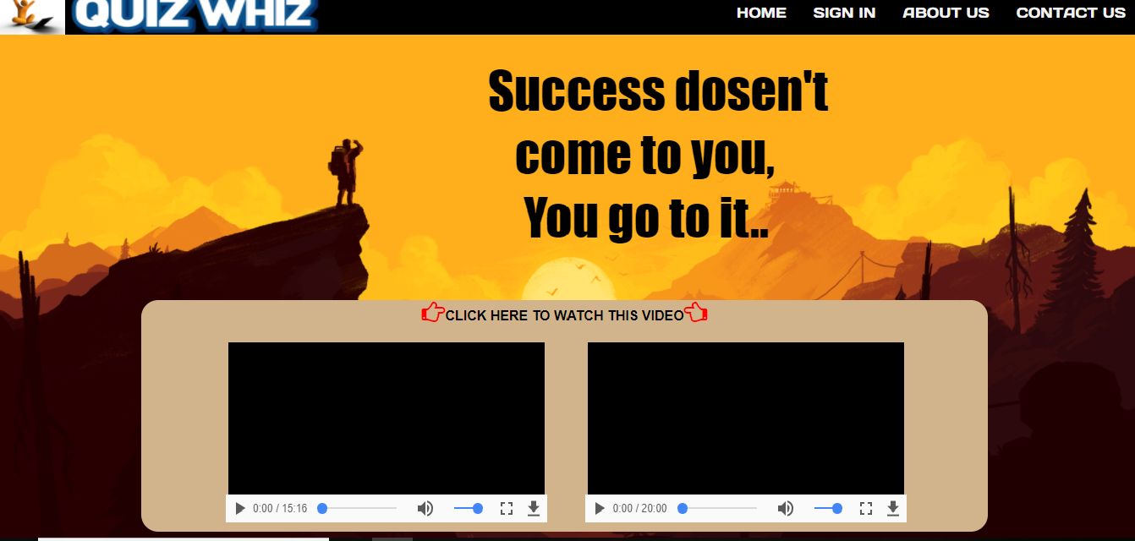

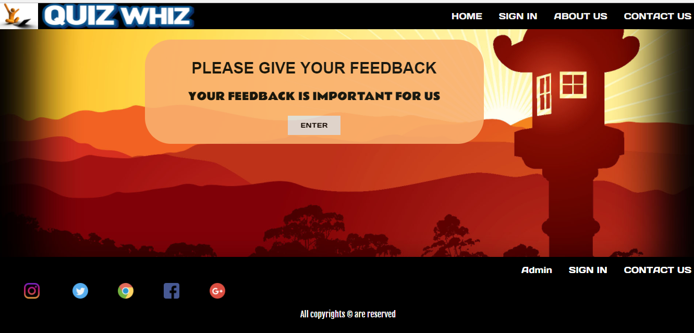

**This is our home page**

**Registration Form**

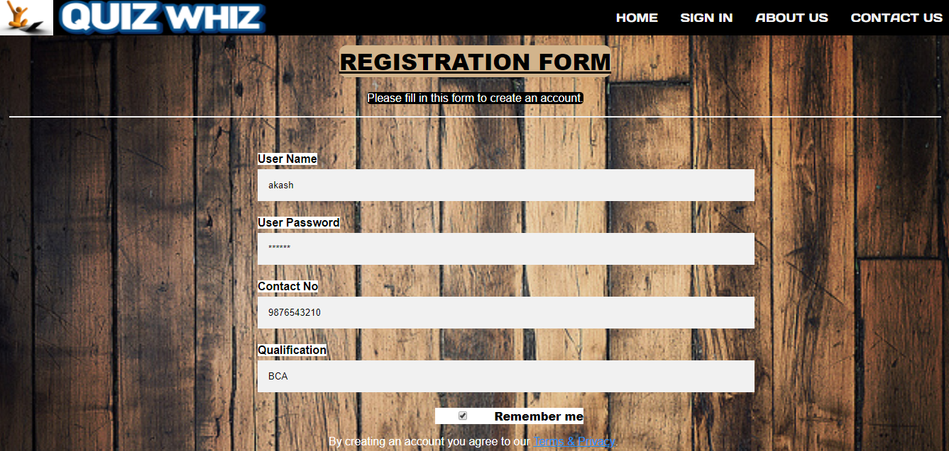

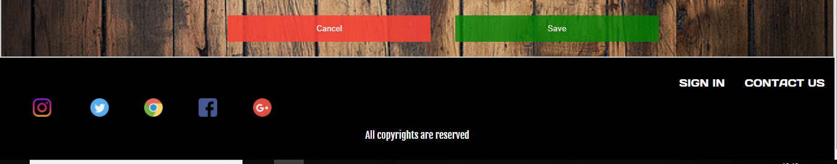

**This is User Registration form**

**Login Form**

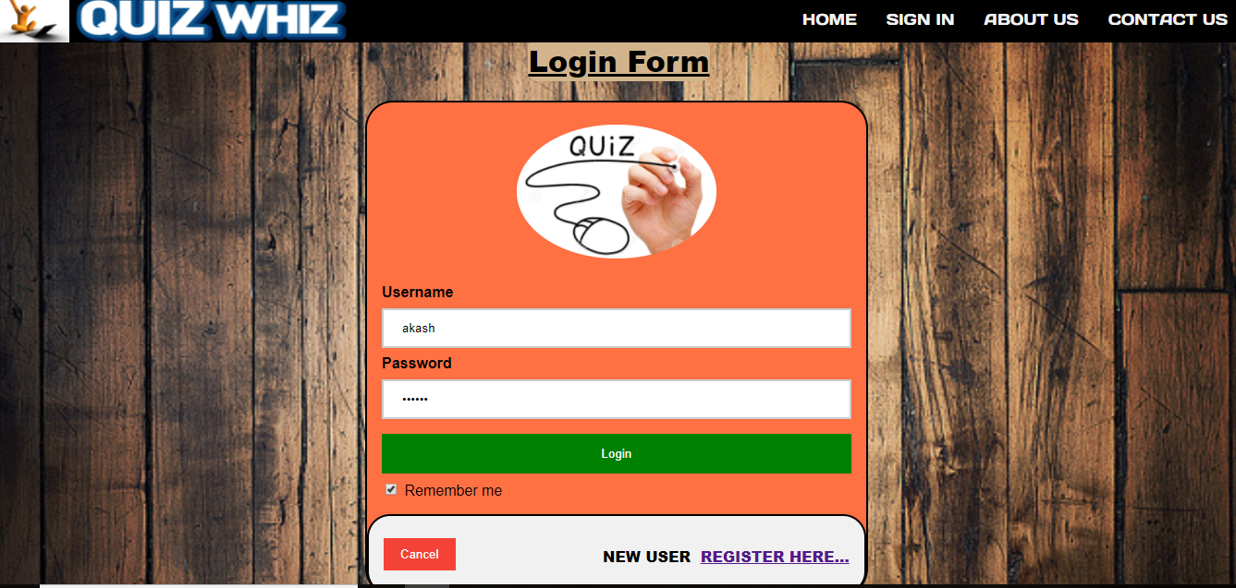

**This is User login form**

**About Us**

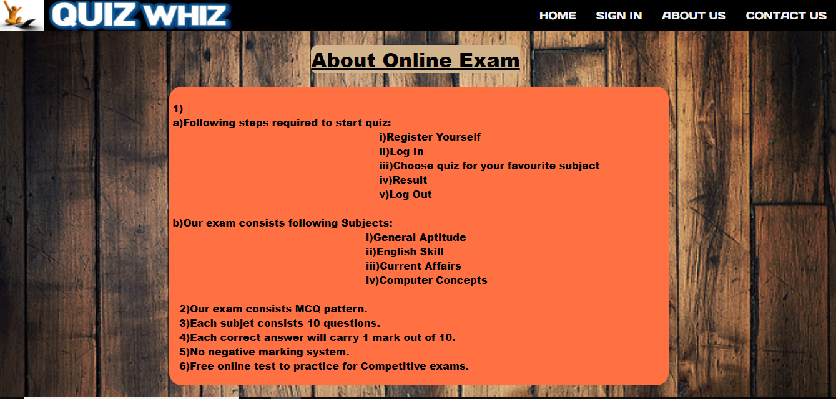

**Information about Quiz**

**Contact Us**

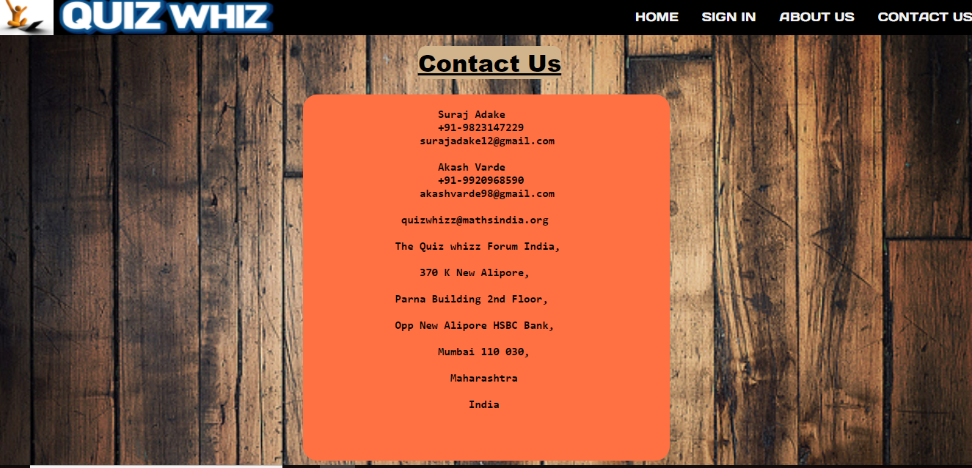

**Information about address and contact details**

**Given Exams**

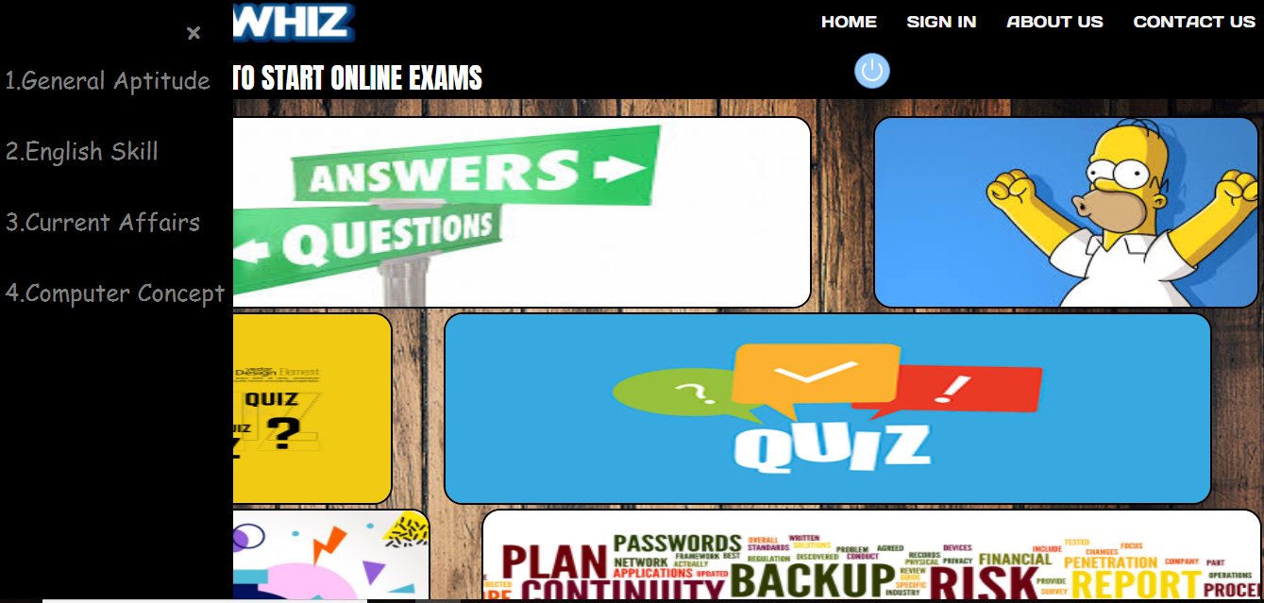

**User can appear any 4 quiz test**

**Start Exam**

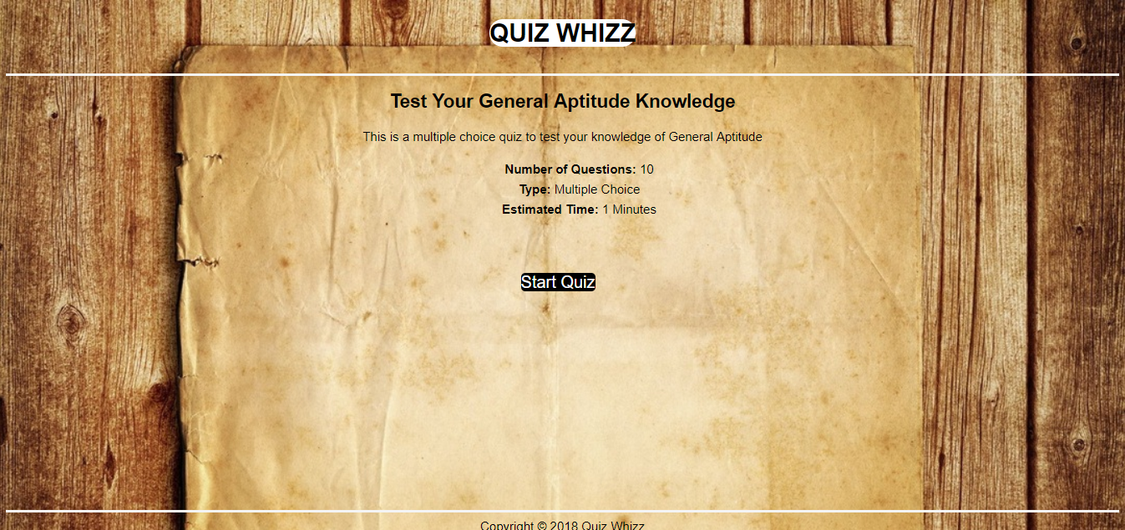

**Starting page after selecting exam**

**Questions**

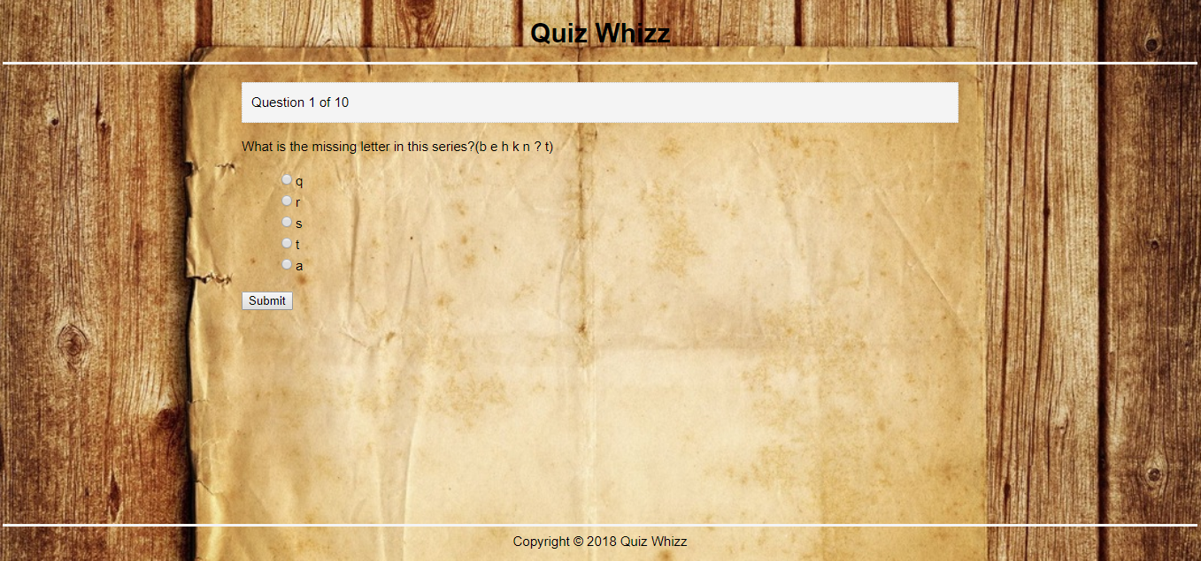

**MCQ question format**

**Score**

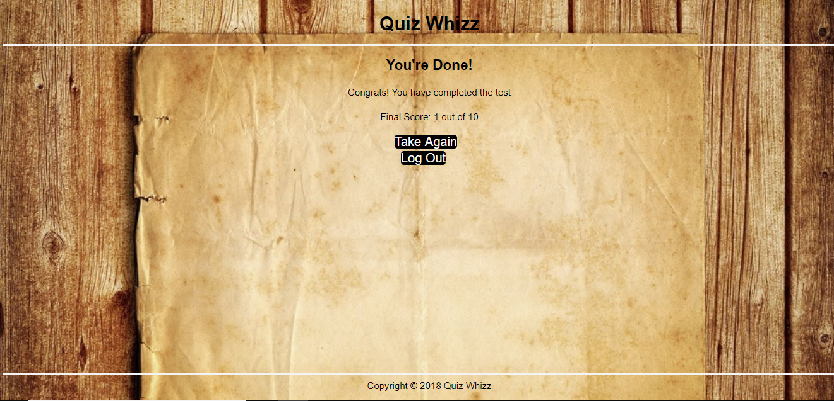

**Display score after exam**

**Feedback Form**

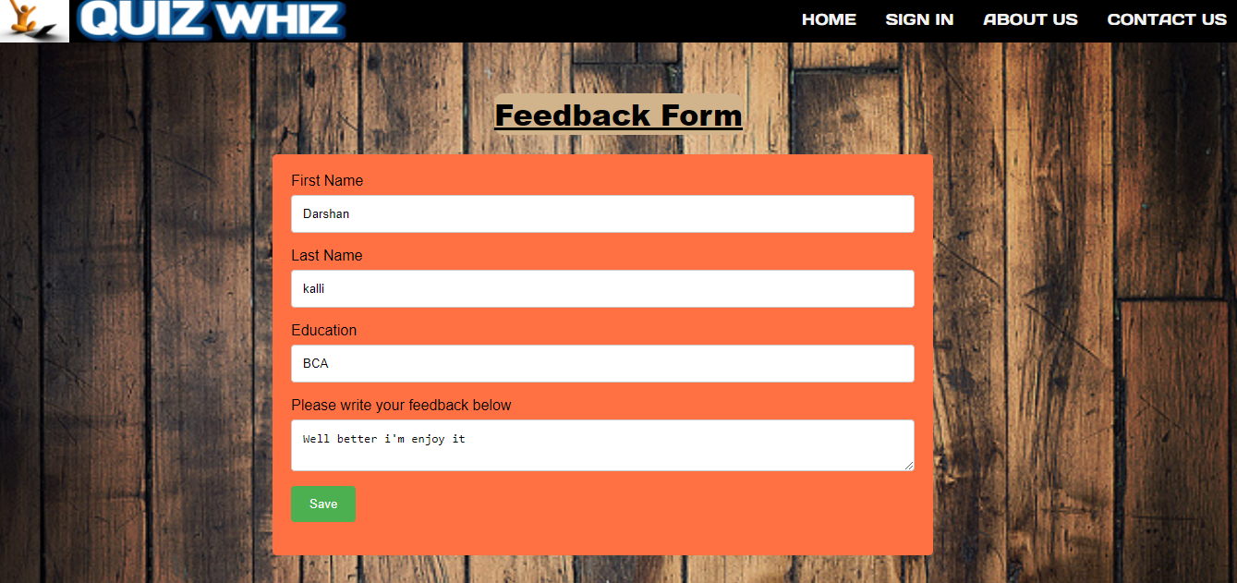

**User feed the information here**

**Admin Login**

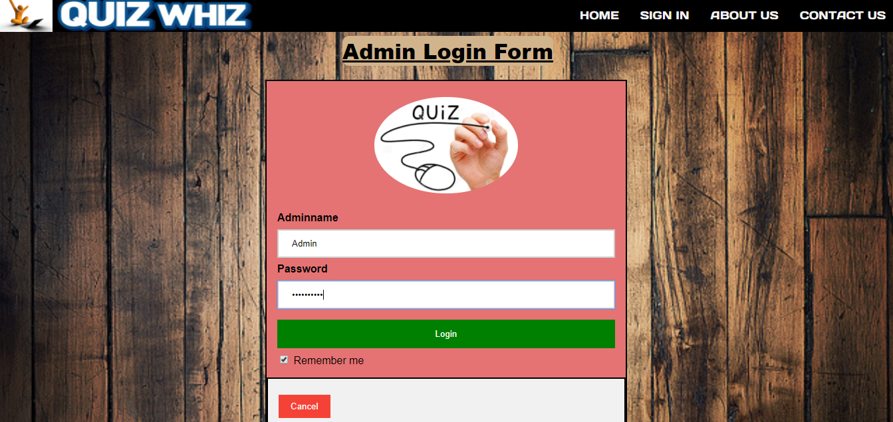

**This is admin login information**

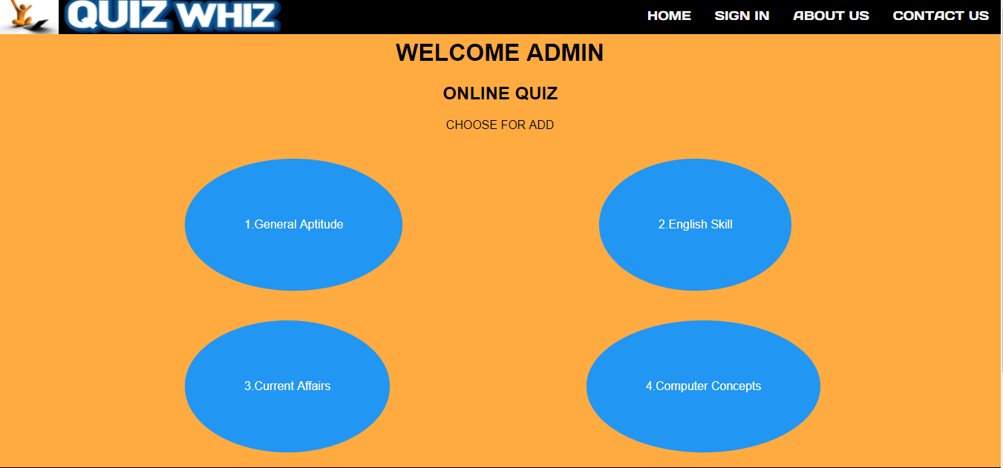

**Admin choose the subject**

**Add Questions**

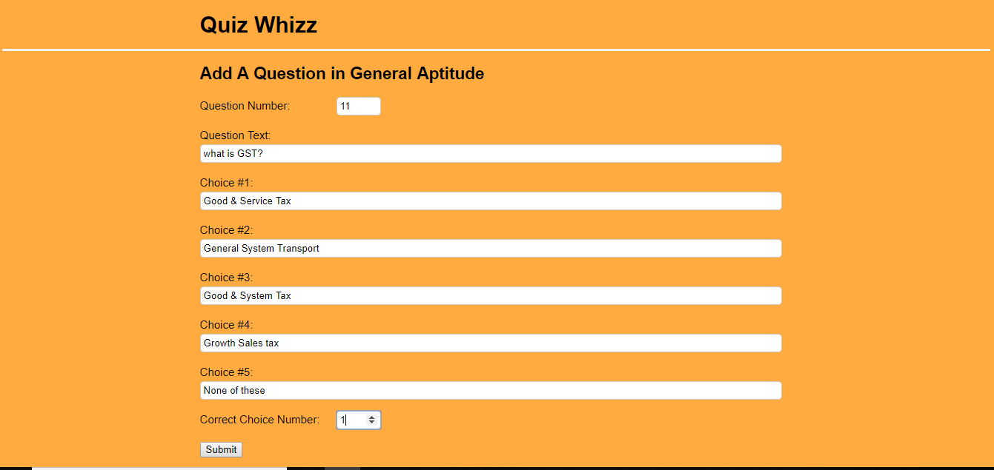

**Admin adds question here**

**FUTURE SCOPE**

There have been numerous cases of computer glitches, errors in content and security lapses reported in online quiz. So in the near future called software could be made more secure and reliable. While electronic glitches are rare, they have been known to occur, for instance when computer crashes voided efforts of thousand of student. There are also cases in which correction software has corrupted score.

So the software can be programmed well so as to avoid Corrupted scores.. The limitation of application is more improve in online quiz. I think if you can get at least your core applications onto a global single instance its accomplished something.

**CONCLUSION**

At the end we have concluded that we have made efforts on following points…

During this project we have accomplished all the objectives and our project needs regarding to PHP. Our project carries all PHP functions. The only limitation of this project is limited era of user information, admin work and it is good source of interactives among students and between the teacher and students.

**BIBLIOGRAPHY**

Web references:-

* <https://w3schools.com>
* [www.lockedowndesign.com](http://www.lockedowndesign.com)
* <https://www.scribd.com>
* <https://stackoverflow.com>

Book References:-

* Beginning PHP & My SQL
* Programming PHP
* Essential PHP Security
* Database System ( Author:- C. J.Date)
* System Analysis and Design (Author:- James A. Senn)